Hardware Design Description
Plantation Productions Open Source/Open Hardware Data Acquisition System
Table of Contents

1 Introduction 4
1.1 Purpose 4
1.2 Scope 4
1.3 Contents of the Document 4
1.4 Document Conventions 4
2 Hardware Architecture 6
2.1 Design Considerations 7
2.1.1 Assumptions and Dependencies 7
2.1.2 Related Software or Hardware 7
2.1.3 End-User Characteristics 7
2.1.4 System Interfaces 7
2.1.5 Fail-Safe 8
2.1.6 Hardware Basis 8
2.1.7 User Interfaces 8
2.1.8 Hardware Interfaces 8
2.1.9 Software Interfaces 9
2.1.10 General Constraints 9
2.1.11 Goals and Guidelines 10
2.1.12 Developmental Methods 11
3 Hardware Design Description 12
3.1 Design Stakeholders 12
3.2 Design Concerns 12
3.2.1 Dow Site Management 12
3.2.2 DTRR Operators 12
3.2.3 NRC 12
3.2.4 DAQ Project Management 12
3.2.5 DAQ Hardware Engineering/Development 12
3.2.6 DAQ Hardware Engineering/Testing 13
4 DAQ Detailed Design 14
4.1 PPDIO96 96-bit Parallel I/O Board 14
4.1.1 Capacity and Interface 14
4.1.2 PPDIO96 Bank Connectors 15
4.1.3 PPDIO96 Power Supply 16
4.2 PPOPTO-12 12-Channel Optical Isolation 17
4.2.1 Capacity and Interface 17
4.2.2 Power Supply 17
4.2.3 Signal LEDs 18
4.2.4 Electrical Isolation and Operating Modes 18
4.3 PPSSR-16 16-Channel Solid-State Relay Board 20
4.3.1 Capacity and Interface 20
4.3.2 Power Supply 21
4.3.3 PPSSR-16 Board Select Signal (BS0) and Clocking Data into the PPSSR-16 22
4.3.4 PPSSR-16 Power-On Reset, Watchdog Latch, and the Reset Signal 23
4.3.5 PPSSR-16 Outputs and Output LEDs 28
4.3.6 PPSSR-16 Buffered Signal Lines 30
4.4 PPRELAY-12 12-Channel Mechanical Relay Board 31
4.4.1 Capacity and Interface 31
4.4.2 Power Supply 32
4.4.3 PPRELAY-12 Board Select Signal (BS0) and Clocking Data into the PPRELAY-12 33
4.4.4 PPRELAY-12 Power-On Reset, Watchdog Latch, and the Reset Signal 34
4.4.5 PPRELAY-12 Outputs and Output LEDs 39
4.4.6 PPRELAY-12 Buffered Signal Lines 41
4.5 PPAIO-16/4 16-Channel Analog Input/4-Channel Analog Output Board 42
4.5.1 Capacity, Interface, and Accuracy 42
4.5.2 PPAIO-16/4 I²C Interface, Port Assignment, and Daisy-Chaining 43
4.5.3 PPAIO-16/4 Power Supply 45
4.5.4 PPAIO-16/4 Analog Output Amplifiers 46
4.6 PPAC4 4-Channel Analog Conditioning Board 48
4.6.1 Capacity and Interface 48
4.6.2 PPAC4 Power Supply 49
4.6.3 PPAC4 Isolation Amplifier Section 49
4.6.4 PPAC4 Amplifier Section 50
4.7 PPAC420 8-Channel 4-20 mA Analog Input Conditioning Board 52
4.7.1 Capacity and Interface 52
4.7.2 PPAC420 Power Supply 52
4.8 PPRLYIO-12 12-Channel I/O Relay Board 53
4.8.1 Capacity and Interface 53
4.8.2 PPRLYIO-12 Power Supply 55
4.8.3 PPRLYIO-12 Relay and Data LED Activation 56

Plantation Productions Open Source/Open Hardware Data Acquisition System
HARDWARE DESIGN DESCRIPTION

Introduction
This document is the Hardware Design Description (HDD) for the hardware contained in the Digital Data Acquisition System (DAQ) created by Plantation Productions, Inc.
The DAQ system provides digital and analog I/O capabilities for embedded systems; specifically, it was designed to provide data acquisition for TRIGA™ Research Reactors (TRIGA is a registered trademark of General Atomics).

Purpose
The purpose of this document is to describe the hardware design for the DAQ system. The intended audiences for this document are the engineering, product assurance and management personnel involved in the hardware development.

Scope
The scope of the software, which is based on the DAQ Hardware Requirements Specification (DAQ HRS) per the requirements that have been allocated to the DAQ system hardware. From this document the hardware will be developed.

Contents of the Document
The general description including product perspective, product functions, user characteristics and general constraints is included in Section 2.
The design descriptions are included in Section 3.
The HDD to HRS traceability (reverse traceability) is documented in a separate document (Excel spreadsheet).

Document Conventions
All tags shall take the form:
<whitespace> [DAQ_HDD_xxx]
where "xxx" is a three-digit number reserved for HDD usage.
For HDD tags, should the need arise to insert a new HDD tag between two other values (e.g., add a requirement between 030 and 031) then a decimal fractional number shall be appended to the HDD tag number (e.g., 031.5). Any number of decimal point suffixes can be added, if needed (e.g., 030.5.2).

Examples:
From the HDD:
<whitespace> [DAQ_HDD_053]

Note: because an external script may be used to extract requirements from this document, it is very important that actual requirements in this document begin on a new line (with nothing but white space preceding the requirement) and that the requirement take exactly the form shown above. The regular expression used by the requirement extraction script is the following:
<whitespace>* '[DAQ_HDD_' {0-9}{0-9}{0-9}('.' {0-9}+)* ']' <whitespace>* ':' <whitespace>* .* '\n'
Where ".*" represents an arbitrary sequence of characters not including a new line and "<whitespace>*" represents zero or more tab or space characters. The actual string "<whitespace>" appears in front of the examples in this section so that they will not be captured by this script; the string "<whitespace>" should not appear in front of actual requirements (though actual whitespace is certainly permissible).

Hardware Architecture
The DAQ digital data acquisition system (Hereafter, "DAQ") consists of several main components:
- DAQ_IF (DAQ interface board). This circuit board interfaces to a single-board computer such as a Netburner MOD54415 Evaluation Board, a Raspberry Pi 3 Model B, or a Teensy 3.2.
- PPDIO96 (96-input digital I/O board). This board connects to the PPDIO96 bus connector on the DAQ_IF board and provides 96 digital I/O pins. Up to six PPDIO96 boards can be connected together in a daisy chain off one DAQ_IF board.
- PPOPTO-12 (12-channel digital input opto-isolation). This board provides 12 channels of digital opto-isolation. This board connects to one of the 12-input bank connectors on the PPDIO96. Up to eight PPOPTO-12 boards can be connected to a single PPDIO96 board providing 96 opto-isolated inputs.
- PPBreakout (12-channel breakout board for PPDIO96). This board connects to one of the 12-input bank connectors on the PPDIO96. It provides 12 sets of two-terminal screw terminals for the 12 I/O pins on that PPDIO96 bank. The PPBreakout board is useful when feeding inputs to the PPDIO96 that do not require isolation or for connecting digital outputs from the PPDIO96 to the rest of the system.
- PPRELAY-12 (12-channel mechanical relay). this board connects to the PPDO bus connector on the DAQ_IF board and provides 12 mechanical relay digital outputs (with NC/NO terminals). In addition, for digital I/O pins capable of sinking up to 150 mA are also available. In theory, an unlimited number of these boards (and PPSSR-16 boards) can be daisy-chained off the PPDO connector. In practice, fan-out limits the system to 10 or fewer boards.
- PPSSR-16 (16-channel Solid-State Relay). This board connects to the PPDO bus connector on the DAQ_IF board (or daisy-chains with other PPSSR-16 and PPRELAY-12 boards). It provides 16 solid-state relay controlled outputs. In theory, an unlimited number of these boards (and PPRELAY-12 boards) can be daisy-chained off the PPDO connector. In practice, fan-out limits the system to 10 or fewer boards.
- PPAIO-16/4 (16 analog inputs, 4 analog outputs). This board connects to one of the four 6-pin I²C connectors on the DAQ_IF board and provides 16 single-ended 16-bit analog inputs (or 8 double-ended inputs) and four 12-bit analog outputs. The analog inputs support up to a 0-5V range (with programmable gain amplifiers allowing the full-range input of smaller signals). The analog outputs include amplifier circuitry to support outputs in the range -10V to +10V (easily programmable as -5V to +5V, if desired).
- PPAC4 (4-channel analog conditioning). This board provides analog isolation and conditioning. The four inputs to this board are single-ended analog signals in the range -10 to +10V. The four outputs from this board are double-ended analog signals (0-4.096V) that provide a full 16-bit range to the PPAIO-16/4 analog inputs. This board also contains isolation amplifiers that isolate the double-ended output from the single-ended input signal.
- PPAC420 (8-channel 4-20mA analog conditioning). This board accepts 4-20 mA current loop inputs and produces a single-ended -1.25 to +5V output. Typically, this outputs would be fed as inputs to the PPAC4 (to provide isolation and full-range ADC conversion), though if isolation is not required the inputs could be fed directly into the single-ended inputs on the PPAIO-16/4 board.

Design Considerations

Assumptions and Dependencies
In the most common use case, the DAQ system will be connected to some host computer via Ethernet, USB, or RS-232 Serial. While it is possible for the DAQ system to operate at a stand-alone data acquisition system, such usage will be rare.

Related Software or Hardware
When running with a Netburner MOD54415 module, the system will be running the µC/OS real-time operating system. When running on a Raspberry Pi, the system will likely be running a variant of the Linux operating system. When running with a Teensy 3.2 module, the software will (likely) be using the Arduino-style library modules provided for the Teensy 3.2.
Because the DAQ system operates using I²C and SPI interfaces, it is quite possible to hook up other I²C and SPI devices. This document will not consider such related hardware.

End-User Characteristics
There are three types of "end-users" associated with the DAQ system: system end users, technicians, and system designers.
System end users (those individual using the final system) may not even be aware of the DAQ system – they are only interested in using the system as a whole and the DAQ system might be a small or hidden part of that whole system.
Technicians are those individuals responsible for maintaining and calibrating the system. Their responsibilities will likely include maintaining and calibrating the components of the DAQ system. As such, they are likely to be concerned with the electronic design and operation of the DAQ system boards.
System designers are those indivduals who design a system around the DAQ system. Clearly, they will require the most knowledge and experience with the DAQ system hardware.

System Interfaces
The DAQ system provides for up to three system interfaces (depending on the computer module controlling the DAQ_IF board): Ethernet (Netburner and Raspberry Pi), USB (Teensy 3.2), and RS-232 (Netburner, Raspberry Pi, and Teensy 3.2).

Fail-Safe
The DAQ system operates in a fail-safe fashion. After a power on restart the PPDIO96 comes up with all the pins programmed as inputs; the PPRELAY-12 and PPSSR-16 digital output boards come up with all the relays turned off (NC in the "C" state, NO in the "O" state, and solid-state relays in the high-impedance state).
The DAQ-IF includes a watch-dog timer that trips a relay if it is not refreshed within 5-10 seconds. If the firmware on the CPU module hangs up or otherwise fails to refresh the watchdog timer within the specified amount of time, a relay will be actuated. The NC/NO outputs from this relay are available for use in the rest of the system (application-defined) to handle the software anamoly. In addition, this signal also appears on the PPDIO96 and PPDO busses. Activation of this signal will place the PPDIO96, PPRELAY-12, and PPSSR-16 boards in the fail-safe state.
Finally, a software programmable line (reset) appearing on the PPDIO96 and PPDO busses will also put the boards into their fail-safe state. Note that the reset line will also reset the watchdog timer if it has expired.
The DAQ_IF board uses a separate digital output line from the CPU module to refresh the watchdog timer. The CPU module must pulse this line (low-to-high edge) at least once every timeout period to keep the watchdog timer from timing out. Note that the watchdog timer is a hardware (RC-based) circuit, it does not depend on software to produce a watchdog timeout.
When designing an end-system around the DAQ system, you should carefully consider the fail-safe design of the DAQ system and wire up any safety-critical systems in an appropriate fashion (e.g., SCRAM loops in a nuclear power reactor).

Hardware Basis
The DAQ hardware is based the data acquisition needs commonly found in TRIGA™ Research Reactors. The design considered the maximum data acquisition requirements for the most complex reactor in existence and then tripled or quadrupled those requirements (in terms of input and output channels) and that became the basis for the design. Because of the generous requirements (up to 576 digital inputs [or outputs], up to 160 relay-controlled outputs, up to 128 analog inputs, and up to 32 analog outputs) the DAQ system should be more than capable for the vast majority of data acquisition projects someone could come up with.

User Interfaces
This document assumes that the DAQ system will be controlled by some host PC. As such, most of the user interface design associated with the DAQ system will occur on the host PC. However, certain user-interface components are present on the DAQ hardware. In particular, all boards will contain a power LED indication power applied to the board (or not). Furthermore, most digital I/O devices provide LEDs for each bit of digital I/O indicating whether the digital I/O pin is active or inactive.

Hardware Interfaces
The DAQ system provides several hardware interfaces to external (to the DAQ) components and systems. As noted earlier, the DAQ system provides Ethernet, USB, and RS-232 interfaces to host computer systems. On the hardware side there are also interfaces to digital inputs, interfaces to digital outputs, interfaces to analog inputs, interfaces to analog outputs, and interfaces to other modules using the I²C and SPI busses.

Ethernet Interfaces
The Netburner and Raspberry Pi 3 Model B single-board computers (SBCs) both provide on-board Ethernet interfaces. These SBCs both contain an operating system with a full TCP/IP stack allowing easy communication across the Ethernet using standard socket communications.
The Teensy 3.2 module does not have a built-in Ethernet interface. However, it is possible to purchase an SPI-based Ethernet interface and wire it to the SPI bus (PPDIO96 bus) on the DAQ_IF interface board if Ethernet access is desired when using a Teensy 3.2 SBC. Note, however, that such connections are beyond the scope of this document.

USB Interfaces
The Teensy 3.2 SBC includes a small micro-USB connector. You may connect the DAQ_IF board (with Teensy 3.2 installed) to a host computer using a USB-to-micro-USB cable. To the host computer, the Teensy 3.2 looks like a really fast COM port.
In theory, the Netburner can also be programmed to act as a USB device. This document will not consider that option.
The Raspberry Pi 3, while it supports USB, cannot be used as a USB device (it's a USB host). Newer Raspberry Pi Zero units can be programmed as a device (using USB On-the-go) but this document will not consider that option.

Software Interfaces
There are software libraries available for the Teensy 3.2 and Raspberry Pi 3 Model B SBCs that allow you to easily program all the I/O chips in the DAQ system. However, the main software written to support the DAQ system runs on the Netburner MOD54415 Evaluation board plugged into the DAQ_IF board. The software interface for this system is completely described in the SRS (Software Requirements Specification), SDD (Software Design Description), and DAQ Operations manual.

General Constraints
- Hardware or software environment – The majority of the software is written in the C/C++ programming language. In addition, there are various "make" files and system scripts used to build or run the system. Some test software is written in C++ running on the Teensy 3.2 or Raspberry Pi, but the majority of the system code runs under µC/OS on the Netburner.
- The software is developed under Windows using the Netburner software development kit and software development tools.

- Availability or volatility of resources – Run within the confines of the Netburner MOD54415 hardware.

- Interface/Protocol Requirements – The basic intertask communication will be handled by Ethernet socket communications.

- Data repository and distribution requirements – In a preemptive multitasking operating system, shared data objects must be protected to insure all access is serialized. Typically, this is done with semaphores, mutexes, or critical sections. To provide the necessary data access protection for globals, the code will include a global semaphore to be used by most tasks. This method will insure serialized data access.

- Memory and other capacity limitations - There will be no memory constraints other than the total amount of system RAM installed MOD54415 module. As the software runs on µC/OS, the system limitations 64 MB RAM and 2 MB Flash/ROM.

- Performance Requirements – The system shall perform all necessary tasks well within the performance capabilities of the MOD54415. During normal operations, all normal I/O and user interface tasks much be completely in less than 25% of the CPU cycles available. Occasional exceptions, lasting no more than a few seconds (less than the DAQ_IF watchdog timeout period), are acceptable as long as these events are infrequent.

- Network Communications – The system shall use TCP/IP Ethernet communications protocols to communicate between the DAQ system and other devices.

- Testing – Testing will follow the standard Plantation Productions, Inc., practices for testing systems, as defined by the HTP (Hardware test procedures) and STP (Software Test Procedures) documents.

- Environmental -- The software shall perform properly while the unit is operating within the environmental constraints for the hardware.

Operating System
The DAQ software will utilize the µC/OS pre-emptive priority-based multitasking operating system kernel for microprocessors. µC/OS was not developed by Plantation Productions, Inc., and may be considered Software of Unknown Provenance (SOUP). However, µC/OS is open-source and its implementation on the Netburner modules has a long history so there is a high confidence in the reliability of this software.
The host computers contain their own software. As the software for those devices is outside the scope of this document, it shall not be considered here.

Criticality of the Application
The hardware may be used as part of a research reactor. The hardware's design allows the support of safety critical systems with an appropriate verification and validation (V&V) process in place.

Personnel Safety and Security Considerations
The hardware must be designed to protect the safety of personnel who use and maintain it.

Goals and Guidelines
Basic hardware goals:
The hardware is designed to operate as programmed under normal circumstances. In anamolous situations (power up, software hang) the hardware shall enter a special fail-safe mode in which all digital I/O ports that are programmable as digital inputs or outputs revert to inputs and all strict digital output ports are programmed in the "off" (or "open") state. To fully realize this in a system, the following guidelines apply:
- The PPDIO96 board should be programmed as input only. Although the system will automatically reset the I/O expander chips to input pins on a reset or watchdog timeout condition, keep in mind that if the pins are actually used as outputs the pins will be floating at that point and won't be in a guaranteed (fail-safe) state immediately after the reset or timeout.
- Before writing to a digital output board (PPRELAY-12 or PPSSR-16) the system software should first verify that a watchdog timeout has not occurred (which will force all the outputs to "off" or "open"). If a timeout has occurred, then the system should reinitialize all the digital outputs to some reasonable state.

Developmental Methods
The developmental method used to design the DAQ system hardware was based loosely on the Prototype/Iterative Model. In this Model, being a process, the following phases were followed in order:
- Requirements Specification
- Hardware Design
- Circuit board creation and assembly
- Testing (validation)
- Repeat steps 1-4 for each new feature or site port.

Hardware Design Description

Design Stakeholders
The initial design of the DAQ system hardware was to support the data acquisition requirements for the Dow TRIGA Research Reactor (DTRR) at Dow Chemical in Midland Michigan. For this project, the project stakeholders are the following:
- Dow Chemical (site management)
- Dow Chemical (site operators/users)
- NRC
- Plantation Productions, Inc., project management
- Plantation Productions, Inc., software engineering/development
- Plantation Productions, Inc., hardware engineering/development
- Faircloth Engineering (systems hardware engineering development)
- Plantation Productions, Inc., software quality assurance

Although this design was originally created for DTRR and Dow Chemical, the design is sufficiently generic to be adopted for a wide variety of embedded applications. As such, the stakeholders can easily be swapped for more stakeholders more pertinent to a given application.

Design Concerns

Dow Site Management
The DAQ design shall provide like-for-like functionality of the existing data acquisition system for DTRR.

DTRR Operators
The console design shall provide a reasonable approximation of the legacy QNX console to reduce the learning curve. This is achieved by providing the like-for-like functionality of the existing console using a similar user interface. In particular, the DAQ system will provide a transparent replacement for obsolete ISA-bus analog and digital I/O boards.

NRC
The DAQ shall follow software quality assurance requirements for research reactors as specified by ANSI 15.15-1978.

DAQ Project Management
The design shall allow implementation, testing, and deployment of the console on schedule and under budget

DAQ Hardware Engineering/Development
The hardware engineering team shall have the following design concerns:
- The design shall provide the functionality required by the SOW, SyRS, and HRS.
- The design shall be efficient in terms of space, power usage, and functionality.
- The design and implementation shall be reliable.
- The design and implementation shall be maintainable.

DAQ Hardware Engineering/Testing
The hardware testing team shall have the following design concerns:
- The design shall produce an appropriate set of test cases.
- The design and hardware shall be such that the system is easy to test.

DAQ Detailed Design

PPDIO96 96-bit Parallel I/O Board

Capacity and Interface
- [DAQ_HDD_013]

The PPDIO96 parallel I/O board provides 96 bits of general-purpose digital I/O using six MCP23S17 GPIO expander ICs (16 bits of I/O per IC). The 96 bits are brought out to eight 20-pin (2x10) headers. The PPDIO96 board also connects eight of the I/O lines (bits 88-95) to an eight-position DIP switch. If these switches are in the open position then it is possible to read the data on the associated 20-pin connector. If the software is actually reading these switches there should be no external hardware connected to D88 through D95. Note that the use of these dip switches assumes that the software has programmed the internal pull-up resistors for these bits inside the MCP23S17 IC.

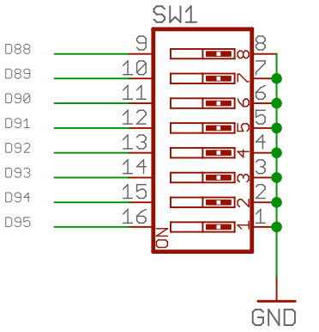

There are two 14-pin headers on the PPDIO96 board that handle data transmission to the DAQ_IF and to other, daisy-chained PPDIO96 boards. One 14-pin header is the input connector (that has the same pinout as the PPDIO96 bus connector on the DAQ_IF board), the second is the output connector that connects to daisy-chained PPDIO96 boards. The input connector has the following pin out (same as the PPDIO96 header on the DAQ_IF):

Pin | Description | Pin | Description
1 | I/O: J2_38 | 2 | Output: WD_LATCH
3 | Output: BS1 | 4 | Gnd
5 | Output: BS2 | 6 | Output: MOSI (SPI data out)
7 | Output: BS3 | 8 | Output: SPI Clk
9 | Output: BS4 | 10 | Input: MISO (SPI data in)
11 | Output: BS5 | 12 | Input: IRQ
13 | Output: BS6 | 14 | Output: Reset

With one (big) exception, the PPDIO96 board passes all the signals on the input PPDIO96 input connector straight through to the output connector. The exception is how it passes the board select lines (BSn) to the following PPDIO96 board in the chain. On output, the board routes the BS2 input to the BS1 output, the BS3 input to the BS2 output, …, and the BS6 output to the BS5 output. BS1 on the input side does not appear on the output connector. BS6 on the output side is tied to Vcc (meaning "never selected").

The PPDIO96 board also buffers all incoming signals it uses (except BS1, because the assumption is that no other boards in the chain will have access to BS1 as it is not passed through to the output connector). These signals include MOSI, SPI Clk, MISO, and Reset. Note that the board does not use the WD_Latch or J2_38 signals, so it doesn't bother buffering these. IRQ is assume to be an open collector/open drain circuit (with a pull-up resistor) so it doesn't bother buffering this signal, either.

Note that the buffer ICs are 74HC125 devices (quad tri-state buffers) whose buffer signals are only active while BS1 is active (low). For the MISO line (input to the DAQ_IF board) these keeps multiple PPDIO96 boards from interfering with one another.

Because of the buffering, the DAQ_IF only presents one TTL load on the buffered signal lines. This allows the daisy-chaining of up to six PPDIO96 boards on the bus without having to worry about logic level drive and fanout problems.
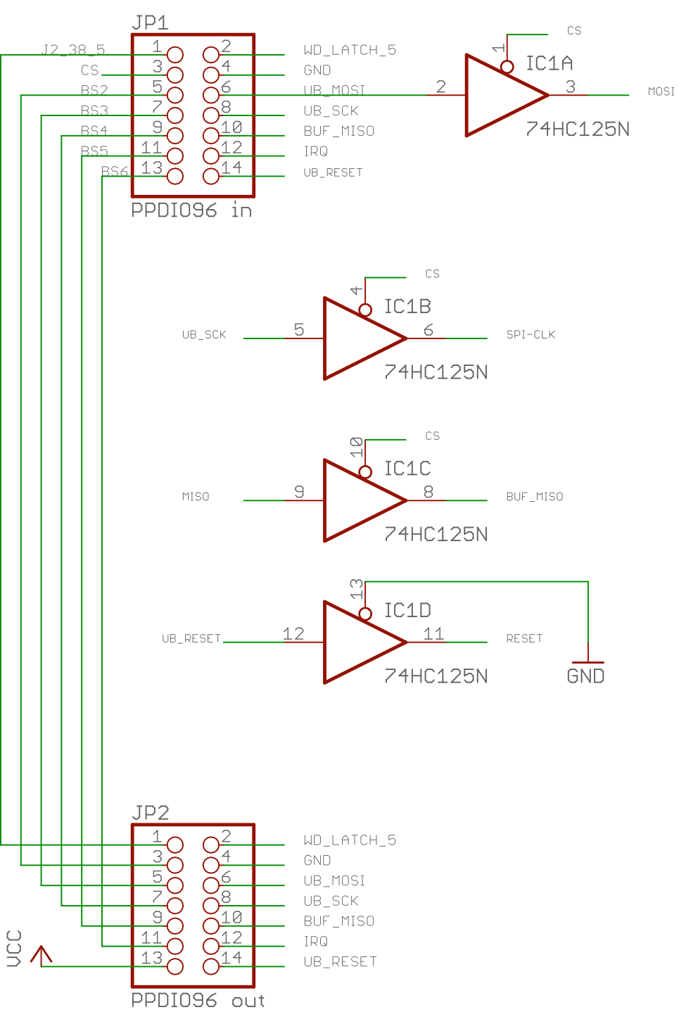

The PPDIO96 board allows the connection of the IRQ pin on each of the MCP23S17 ICs to the IRQ bus by installing a jumper block on the INTA header associated with each chip.

PPDIO96 Bank Connectors
- [DAQ_HDD_014]

The PPDIO96 parallel I/O board has eight 20-pin connectors labeled "Bank 0" through "Bank 7". These connectors each have the following pinout:

PPDIO96 Bank Pinout for Bank headers 0-7
D(1+bank*8) is the data line for bank = 0 through 7
Pin | Description | Pin | Description
1 | D(1+bank*12), e.g., D1 for bank 0 | 2 | D(0+bank*12), e.g., D0 for bank 0
3 | D(2+bank*12), e.g., D2 for bank 0 | 4 | Gnd
5 | D(3+bank*12), e.g., D3 for bank 0 | 6 | Gnd
7 | D(4+bank*12), e.g., D4 for bank 0 | 8 | Gnd
9 | D(5+bank*12), e.g., D5 for bank 0 | 10 | Gnd
11 | D(6+bank*12), e.g., D6 for bank 0 | 12 | Gnd
13 | D(7+bank*12), e.g., D7 for bank 0 | 14 | Gnd
15 | D(8+bank*12), e.g., D8 for bank 0 | 16 | Gnd
17 | D(9+bank*12), e.g., D9 for bank 0 | 18 | Gnd
19 | D(10+bank*12), e.g., D10 for bank 0 | 20 | D(11+bank*12), e.g., D11 for bank 0

In the table above, the particular bit number on a bank is computed by a bit number in the range 0..11 plus the bank number times 12

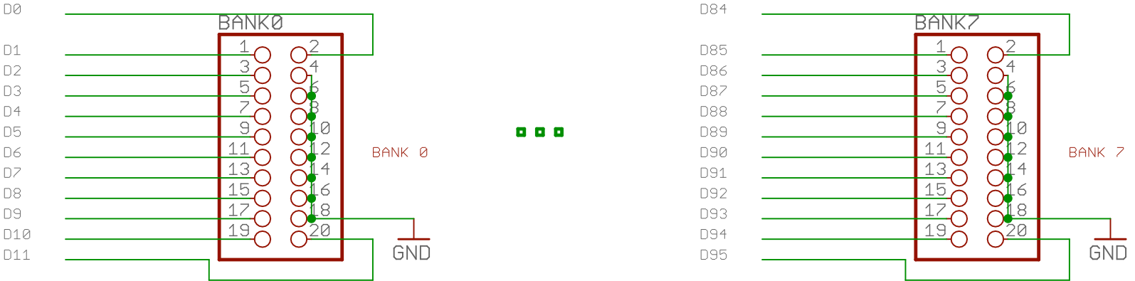

In order to fit four bank headers across the length of the board, the headers only provide 8 (common) ground pins rather than the 12 ground pins one would normally expect on such a header. The MCP23S17 does not source or sink much current per pin and the signals are not isolated from one another, so having separate ground pins isn't (electrically) necessary. By using only 8 ground pins, the bank header requires only 20 pins rather than 24, saving board space. Eight ground pins is certainly sufficient for the small amount of current 12 pins from the MCP23S17 will carry.

PPDIO96 Power Supply
- [DAQ_HDD_015]

The PPDIO96 parallel I/O board runs off a +5V power supply. As with most DAQ system boards, the PPDIO96 board illuminates an LED when power is applied to the board.

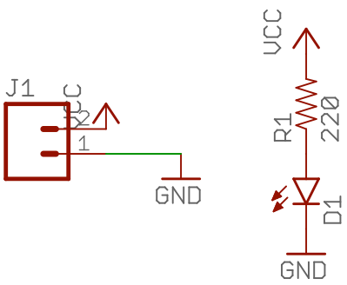

PPOPTO-12 12-Channel Optical Isolation

Capacity and Interface
- [DAQ_HDD_016]

The PPOPTO-12 board provides 12 channels of optical isolation for digital input devices. It provides 12 sets of screw terminals (two terminals each) as inputs and a 20-pin (2x10) header that connects to one of the bank headers on the PPDIO96 board. In addition to the 12 screw terminal pairs, the PPOPTO-12 board also provides a 24-pin header (2x12) that allows a ribbon-cable connection as input to the board.

Each screw terminal has a positive (signal) and negative (ground) terminal, as indicated on the circuit board. The pinout for the 24-pin header is as follows:

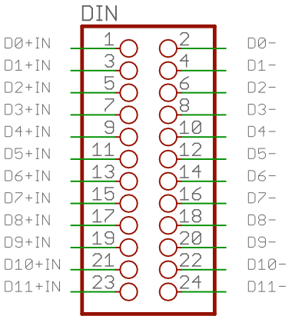

Pin | Description | Pin | Description
1 | D0+ in | 2 | D0- in (Gnd)
3 | D1+ in | 4 | D1- in (Gnd)
5 | D2+ in | 6 | D2- in (Gnd)
7 | D3+ in | 8 | D3- in (Gnd)
9 | D4+ in | 10 | D4- in (Gnd)
11 | D5+ in | 12 | D5- in (Gnd)
13 | D6+ in | 14 | D6- in (Gnd)
15 | D7+ in | 16 | D7- in (Gnd)
17 | D8+ in | 18 | D8- in (Gnd)
19 | D9+ in | 20 | D9- in (Gnd)
21 | D10+ in | 22 | D10- in (Gnd)
23 | D11+ in | 24 | D11- in (Gnd)

Power Supply
- [DAQ_HDD_017]

The PPOPTO-12 uses a single +5V power supply that comes in on a two-conductor pair of screw terminals. As for most DAQ system boards, applying power also illuminates an LED indication power on.

Signal LEDs
- [DAQ_HDD_018]

Each isolated channel on the PPOPTO-12 provides an LED to indicate whether that channel is active or inactive. The LED is illuminated when the channel is active and the LED is off when the channel is inactive. "Active" means that the input pins are shorted when operating in "dry contact" mode, it means that an appropriate voltage level appears on the Dn+ pin (relative to the Dn- pin, where n is a channel number in the range 0 to 11) when not in "Dry Contact" mode.

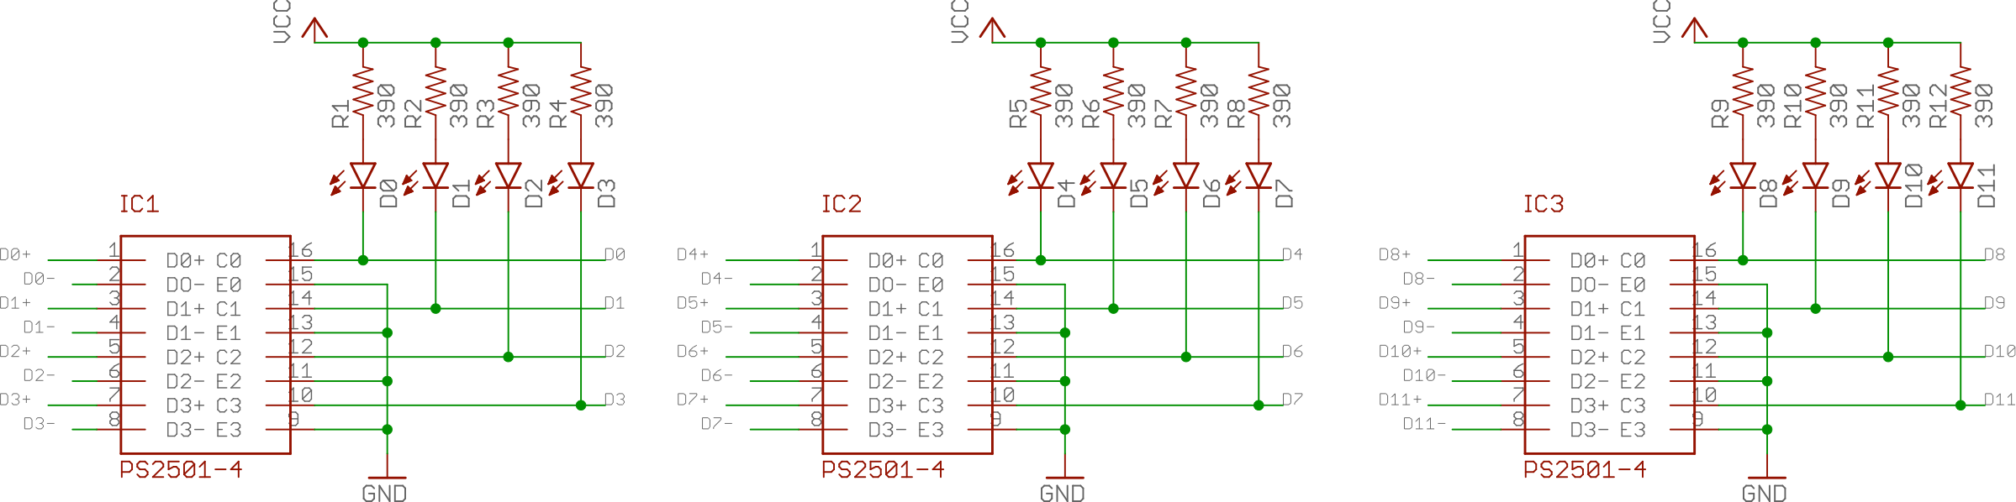

Electrical Isolation and Operating Modes
- [DAQ_HDD_019]

Each channel on the PPOPTO-12 is isolated from all the other channels as well as being isolated from the digital outputs from the board (i.e., isolated from the PPDIO96 board). Isolation is achieved using two different ICs per channel. First of all, a PS2501-4 optical isolation chip isolates each channel from the rest of the DAQ system (specifically, the PPDIO96 board). Second, an isolation power supply (CRL2S) provides an independent and isolated power supply for each channel (when operating in "Dry Contact" mode).

The PS2501-4 is a quad opto-isolation package with each channel containing an LED (driven by the circuit to be isolated) and photo detector (providing a signal to the isolated system, in this case the PPDIO96 board). When the circuit to be isolated turns the LED on, this creates a low-impedance condition across the photo detector that the DAQ system sees as a switch closure. A typical optical isolation device such as the PS2501-4 offers better than 1000V isolation.

The circuit to be isolated (that is, the input to the PPOPTO-12 channel) must supply an appropriate current-limited voltage to drive the LED inside the PS2501-4 package. If the external circuit produces an appropriate voltage (the specifications allow for voltages in the range 5V to 24V) all that is necessary is an appropriate current limiting resistor in series with the input of the PS2501-4. For 5V inputs, a resistance of approximately 470 Ω. For 10-12V a 1 kΩ resistor suffices. For 15V use a 1.5 kΩ resistor in series with the PS2501-5. And so on for other voltages.

Often, the digital inputs to a system (such as the PPOPTO-12 channels) are "Dry Contact" inputs rather than voltage or logic levels. A dry contact input is something like a switch or relay contact where the signal consists of a shorted pair of input wires or an open pair of input wires. For dry contact inputs the PPOPTO-12 channels provide a +5V power source (though a pull up resistor). The +5V signal, when the dry contact is open, turns on the LED. When the dry contact is shorted, this pulls the +5V signal to ground, turning off the LED (and putting the photo conductor in a high impedance state).

A 4-pin (2x2) header on each input channel allows you to program that channel for dry contact or voltage level operation. Putting jumper blocks on pins 1-3 and pins 2-4 programs the device for dry contact operation. In this mode, closing the contacts across the D+ and D- inputs will pull the D- Out signal (connected to the PS2501-4 input) to ground, while feeding +5V to the other leg of the LED in the PS2501-4. This turns the LED on (and activates the photo detector). When the D+ and D- inputs are not shorted, +5V is still being fed to the anode of the LED but the cathode leg is floating. Thus the LED is off (and the photo detector goes into high impedance mode).

Putting a jumper block on pins 3-4 (and leaving pins 1-2 open) on the jumper block disconnects the isolated power supply from the circuit and feeds the D+ input signal directly to the anode input of the PS2501-4 LED (the D- input remains connected to the LED's cathode). In this mode, an appropriate positive voltage (relative to D-) turns the LED on.

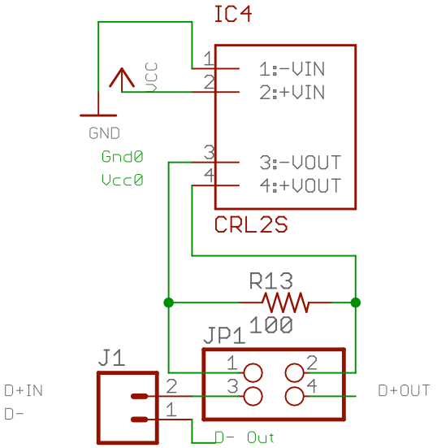

You will note that there is a 100 Ω (1/2 watt) between the isolated Vcc and Gnd on the CRL2S. This resistor is present because isolated power supplies require at least a 10% load or the output voltage can rise (to almost double the rated output voltage). As the LED doesn't represent much of a load to the power supply, the 100 Ω resistor guarantees that there is at least a 10% load on the circuit. Note that if you're not using the dry contact mode for a particular channel, you can save several dollars by not populating the board with the CRL2S isolated power supply (which isn't especially cheap); this will also reduce power consumption on the board as the 100 Ω resistor won't be acting as a quarter-watt heater in the system.

PPSSR-16 16-Channel Solid-State Relay Board

Capacity and Interface
- [DAQ_HDD_020]

The PPSSR-16 board provides 16 channels of solid-state relay control for digital output devices. It provides 16 sets of screw terminals (two terminals each) as outputs and a pair of 10-pin (2x5) headers that connect to the PPDO connector on the DAQ_IF board and provide a daisy-chain output to another output board.

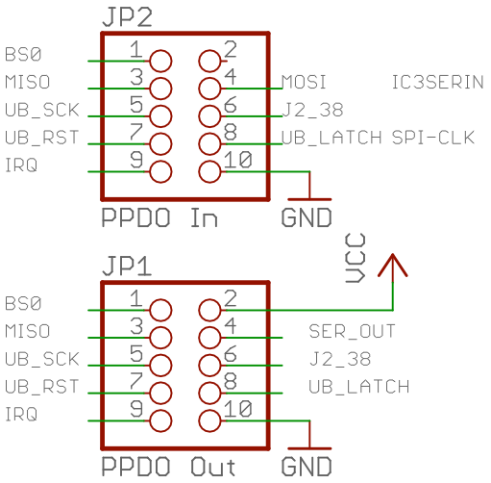

The PPDO input connector is a 10-pin header (2x5) with the following signals:

Pin | Description | Pin | Description
1 | Output: BS0 (SPI Chip Select) | 2 | N/C
3 | Input: MISO (SPI input) | 4 | Output: MOSI (SPI output)
5 | Output: SPI Clk | 6 | I/O: J2_38
7 | Output: RESET | 8 | Output: WD_LATCH
9 | Input: IRQ | 10 | Gnd

The PPDO output connector is nearly identical, with the following signals:

Pin | Description | Pin | Description
1 | Output: BS0 (SPI Chip Select) | 2 | Vcc
3 | Input: MISO (SPI input) | 4 | Output: MOSI (SPI output)
5 | Output: SPI Clk | 6 | I/O: J2_38
7 | Output: RESET | 8 | Output: WD_LATCH
9 | Input: IRQ | 10 | Gnd

The differences are on Pin 2 and pin 4. The input connector (+5V from the previous board in the daisy-chain) is left disconnected on the input connector. Pin 2 is connected to Vcc (+5V) on the output connector. Pin 4 on the input connector is tied to the serial in pin of the first TPIC6B595 serial shift register. Pin 4 on the output connector is tied to the serial out pin of the second TPIC6B595 IC (Serial data flows into the first shift register, out of the first and into the second shift register, and then out of the second shift register and to the output connector).
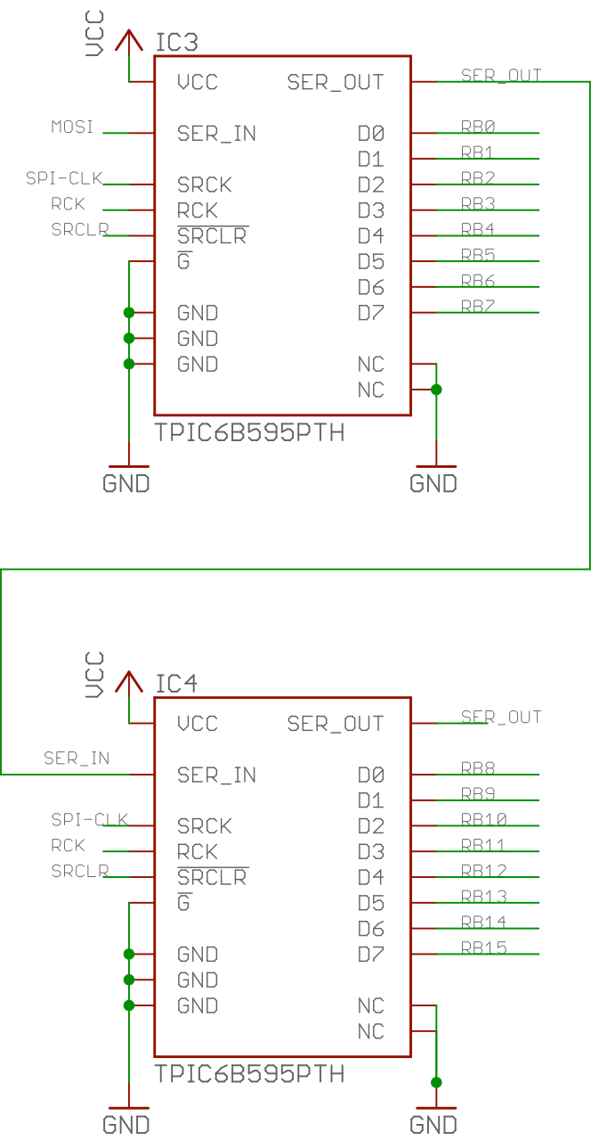

As the PPSSR-16 board is a digital-output-only board, the PPSR-16 ignores the MISO input pin.

Power Supply
- [DAQ_HDD_021]

The PPSSR-16 receives +5V power and ground on a two-pin screw terminal. As with most DAQ system boards, there is an LED connected to the power supply to indicate when power is applied.

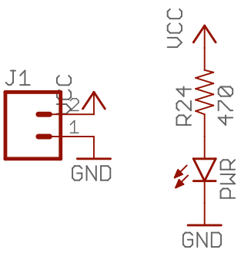

The greatest power use on the board will be the current required to actuate the solid-state relays. For the AQZ-10 SSR an LED drives the relay with a maximum forward current of 50 mA (though the maximum turn-on current is 3mA). Therefore, absolute worst case, is 16* 50mA or 800 mA of current to the board. In reality, there is a 390 Ω resistor in series with the LED, so with a +5V supply expect less than 15 mA per circuit (total 240 mA) if all relays are activated. In addition to the LED inside the SSR, there is an LED associated with each output channel that illuminates whenever the SSR is actuated. These LEDs have a 470 Ω resistor, so each LED will also consume just under 15 mA. Of course, the rest of the board also draws current, so it's not unreasonable to expect upwards of 500 mA to be pulled from the power supply when all relays are actuated.

Note that the power switched by the relays is (theoretically) independent of the power supplied to the board. Unless you are powering some external circuit being switched by the relays from the PPSSR-16's power supply, their power usage doesn't count towards the power used by the board.

PPSSR-16 Board Select Signal (BS0) and Clocking Data into the PPSSR-16
- [DAQ_HDD_022]

The PPSSR-16 contains three input signal lines that control shifting data into the TPIC6B595 shift register and transferring that data to the output latches: BS0, SPI-CLK, and MOSI. These three signals correspond to three of the four SPI control lines (CS, SCK, and MOSI; as an output line the fourth SPI control line, MISO, is not used).

Note: although the PPSSR-16 board uses the SPI control lines, the PPSSR-16 isn't, technically speaking, an SPI device. It just so happens that the SPI clock and MOSI lines work fine as inputs to the TPIC6B's shift in and clock inputs. This "grand coincidence" allows the DAQ system to use the SPI bus to control shift-register-based digital output boards (e.g., PPSSR-16 and PPRELAY-12) on the system SPI bus.

To shift data into the two TPIC6B595 shift registers on the PPSSR-16, the system should first switch the BS0 (board select 0) from high to low. The BS0 signal must be held low for the entire shift duration. Note that if you connect multiple PPSSR-16 (and PPRELAY-12) boards in a daisy-chain on a single PPDO bus (i.e., off a single DAQ_IF board) then you must hold BS0 low while shifting out the bits for all boards. For example, if you have three output boards connected in a daisy chain, you need to hold BS0 low while shifting out all 48 bits for the three boards.

The TPIC6B595 shift registers shift the data present on the SER_IN pin into the shift register on the rising edge of the SRCK (SPI-CLK) signal. As in turns out, this is the exact waveform you want when transmitting data on the SPI bus. The bit shifted out appears on the SER_OUT pin that you normally feed to the input of any additional TPIC6B595 ICs in the chain.

On the rising edge of the BS0 signal, the PPSSR-16 boards copy the bits in the shift register over to the output latch. To transfer the bits, a rising-edge clock signal must appear on the TPIC6B595 RCK input. The PPSSR16 synthesizes this clock by putting a positive-edge detection circuit on the BS0 input:

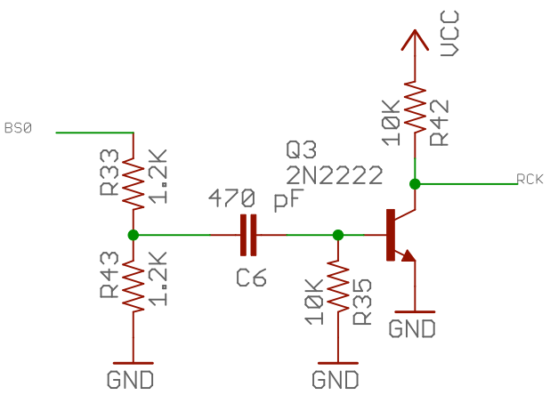

On the rising edge of the BS0 signal the transistor momentarily (about 5 µSec = C6 * R35) conducts pulling the RCK signal low for that time period. On the rising edge of that 5 µSec pulse (which occurs at least 5 µSec after BS0 has gone high) the TPIC6B595 shift register copies the data from the input shift register to the output latch.

PPSSR-16 Power-On Reset, Watchdog Latch, and the Reset Signal
- [DAQ_HDD_023]

The PPSSR-16 board, by requirement, must enter a "fail-safe mode" whenever power is first applied, whenever there is an explicit reset operation (a low pulse on the reset pin), or whenever the DAQ system has a watchdog timeout (low signal on the WD_LATCH input pin).

A "fail-safe mode" is defined as follows:
- If no power is applied to the PPSSR-16 board, the solid-state relays remain in a high-impedance (non-conducting) state. This state is guaranteed as the AQZ-10 solid-state relays consist of an LED and photo-senstive MOSFET circuit. With no light from the photo MOSFET the FET does not conduct. Without power to the board, the LED will not illuminate. So the "unpowered" fail-safe condition is assured.
- On power-up the system remains in a fail-safe condition (high impedance/non-conducting) state until explicitly programmed to enter a low-impedance/conducting state.
- When explicitly told to reset, the system enters a fail-safe condition.
- When an anamolous condition (watchdog timeout) occurs, the system enters a fail-safe condition.

To handle the power-on reset requirement, the board includes a DS1834 power-on reset IC (with push-button input). The DS1834 provide three ways of generating a power-on reset signal:

- A power-on condition on a 5V power supply,
- A power-on condition on a 3.3V power supply, or
- An explicit reset request on a push-button input.

In the default state the PPSSR-16 uses the first and third modes on to DS1834 to put the system in a "fail-safe" state.

Important note: there are several variants of the DS1834 IC. The DS1834 (no suffix) has an active-low RST output. The DS1834A has an open-collector RST output. The DS1834D has an active-high RST output. The PPSSR-16 design utilizes the DS1834 (active-low) version.

The PPSSR-16 uses a 5V power supply. Therefore, by default, the PPSSR-16 uses the 5V side of the DS1834 to produce a power-on reset. The PPSSR-16 board programs the DS1834 with a 10% tolerance. So if the voltage drops below (approximately) 4.5 volts (assuming a true 5V input) the chip with generate a reset pulse when power resumes. As it turns out, both the 5V and 3.3V sides of the chip will accept up to 5.5V on their input pins. The only difference is when they will produce a reset condition (4.5V or 3.0V). If your 5V power supply input to the PPSSR-16 is right on the edge of 4.5V and you're getting spurious resets from the DS1834, you can choose to use the 3.3V power-on-reset function rather than the 5V power-on-reset function. This is accomplished using the DS1834SEL jumpers on the PPSSR-16 board. Putting jumpers between pins 1 & 3 and pins 2 & 4 programs the device to use the 5V power-on-reset (this is the default). Moving the jumpers to pins 3 & 5 and 4 & 6 programs the DS1834 to use the 3.3V power-on-reset. Note that you're still feeding 5V to the chip (which, electrically, is okay). By using the 3.3V inputs you're providing a 40% tolerance factor rather than the normal 10% tolerance factor. In practice, there is almost no reason to do this; you will not normally see voltage drops greater than 10% on the board (and if you have a flakey power supply that doesn't provide a good five volts, you should probably replace that first). However, the option is there if you want it.

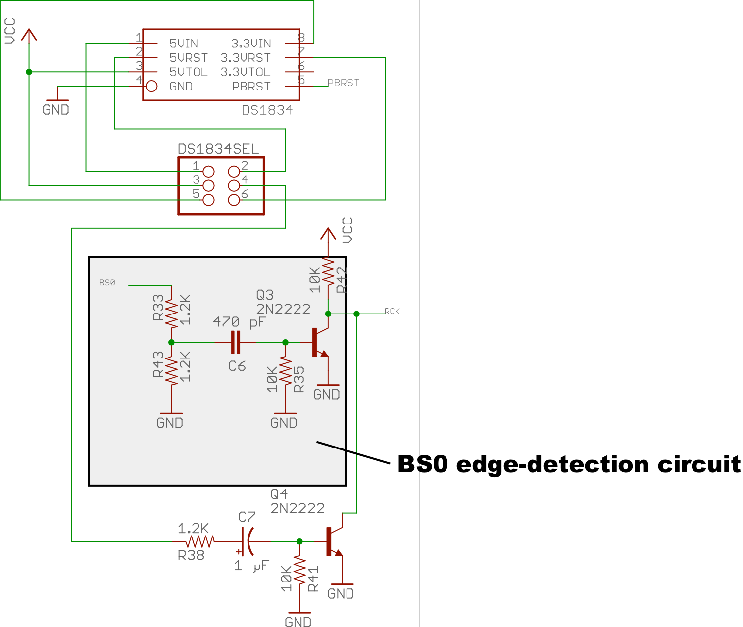

The reset output (5VRST or 3.3VRST, depending on the jumpers on DS1834SEL) is fed into a positive edge detector circuit (similar to the BS0 edge detector circuit) and this is connected to the RCK signal line (along with the collector on the BS0 edge detector). If either signal, BS0 or the DS1834 RST output, goes low, you get a negative-going pulse on the RCK (register transfer clock) input to the TPIC6B595 shift register.

Note that the time constant for the DS1834 RST edge detector is much longer than that of the BS0 edge detector (10 mSec for the DS1834 versus 5 µSec for BS0). The DS1834 PBRST input requires an active low-signal for at least 2 mSec. The time constant for the RCK pulse is 10 mSec because it is greater than or equal to the pulse being sent to the DS1834 (that triggers the RST pulse).

If, by some coincidence, both BS0 and the DS1834 RST signals occur are the same time, whomever holds the RCK line down the longest (usually the DS1834) will be the winner. Of course, if the DS1834 RST signal is active, the circuitry is clearing the shift register anyway, so ithe data shifting into the shift register will be irrelevant. One important feature, and in fact the main reason for implementing the edge detectors in the RCK signal circuit, is that the static state of either input signal (DS1834 RST or BS0) does not affect the operation of the other signal. That is, if BS0 is held low (or held high) it doesn't prevent the DS1834 from clocking the TPIC6B595 RCK line. Likewise, if the PBRST is held low (or high) it doesn't prevent BS) from generating a clock on the RCK line. Had this been just the logical NAND of the two signals, errant software could leave the BS0 line low (for example) and then the DS1834 circuit would not be able to clear the shift register and shift those zeros into the output latch (putting the system in fail-safe mode).

Note that there is no feedback to the DAQ system (other than putting the output latches on the PPSSR-16 into fail-safe mode) that there has been a power failure and reset on the PPSSR-16 board. If this is a possibility in your system design, you will need to add monitoring circuitry to check for this.

The PPSSR-16 synthesizes the DS1834 input PBRST signal from two PPDO input signals: WD_LATCH and RESET. The WD_LATCH signal is active low whenever the watchdog timer has expired, the RESET signal (not to be confused with the DS1834 RST output) is active low whenever the DAQ_IF CPU module programs the system to do a reset operation.

The PPSSR-16 circuit feeds the WD_LATCH and RESET signals into edge detector circuits and combines their outputs to feed the PBRST input on the DS1834 IC.

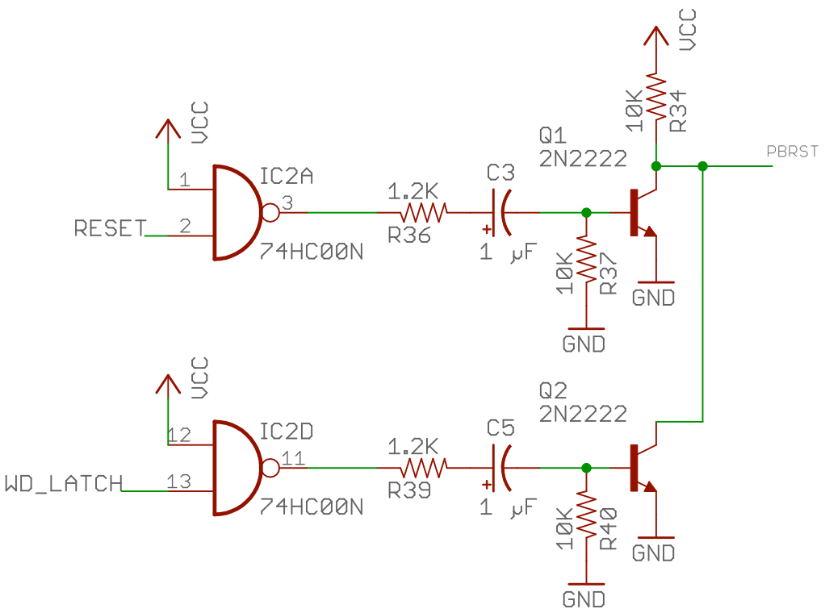

Note that this circuit inverts the two input signals. Therefore, the positive-edge detector circuits are actually producing pulses on the negative-going edges of these two signals (that is, on the leading edge of the RESET and WD_LATCH pulses, which are normally active-low pulses). Because the PBRST input on the DS1834 IC requires an active-low signal at least 2 mSec in duration, the time constants on the two edge detector circuits is 10 mSec. This means that these signals should be held low for at least 10 mSec to guarantee a full 10 mSec output pulse.

Note that pulsing (low) the RESET or WD_LATCH line will (eventually) generate a pulse on the RCK line. This, alone, however, does not put the system into the fail-safe state. Pulsing RCK will transfer the current data from the TPIC6B595 shift register to the output latch; however, if the contents of the shift register are not zero this will not produce a fail-safe output condition. Therefore, activation of either RESET or WD_LATCH must also clear the shift register prior to transfering the data from the shift register to the output latch. The system must pulse (low) the TPIC6B595 SRCLR line to clear the contents of the shift register.

The PBRST signal is almost the signal needed to accomplish this. PBRST goes low whenever RESET or WD_LATCH become active. Furthermore, this signal will be low prior to the RCK clock pulse that PBRST generates, so the timing is perfect for the TPIC6B595 chip:

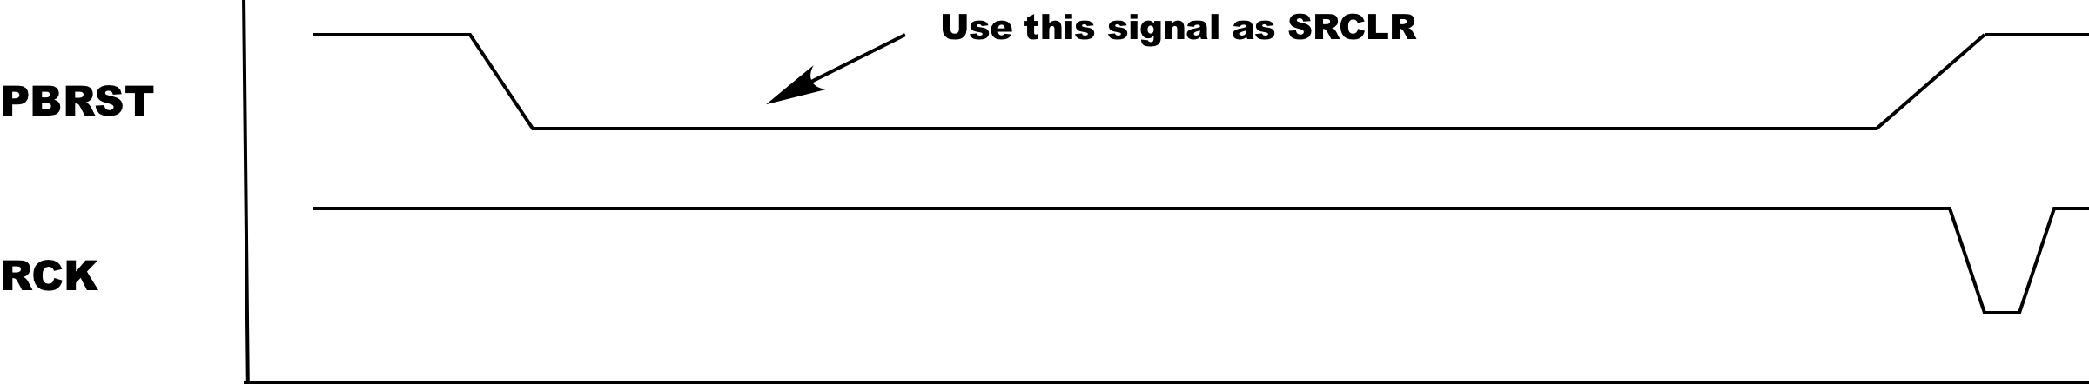

The only problem here is that to clear the TPIC6B595 shift register requires a rising edge on the PBRST line. Because of the edge detector circuitry, this rising edge is pretty much guaranteed around 10 mSec after PBRST first goes low because it is totally dependent upon the RC time constant in the two edge detectors (C5*R40 or C3*R37 in the previous schematic). For the reset signal, this is no big deal because software generates the reset pulse (and failure of the software to bring the reset signal high won't affect the behavior of this circuit).

The WD_LATCH signal, however, is generated in hardware (a watchdog timeout on the DAQ_IF board). This signal is set low whenever the watchdog timer times out and remains low until the CPU module on the DAQ_IF explicitly resets it to high by toggling the RESET line. Note that refreshing the watchdog timer (by pulsing the WD_RFSH line on the DAQ_IF board) will not clear the WD_LATCH low condition. Only an explicit active low signal on the RESET signal will set the WD_LATCH signal back to high. For most situations, a system designer would probably like to keep the output latches in their fail-safe state as long as the WD_LATCH signal persists. Some additional circuitry exists in the PPSSR-16 design to allow this:

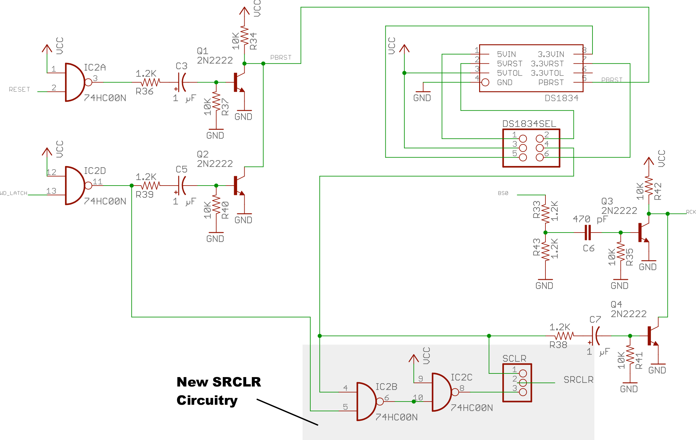

This circuit includes a 3-pin header that allows the system designer to select PBRST-only operation (only clearing the shift register on while PBRST is active low) or a combination PBRST or WD_LATCH active-low condition. If there is a jumper between pins 1 & 2 on the SCLR header, the system only resets the shift register while PBRST is low. If there is a jumper between pins 2 & 3 on the SCLR header, then the system will keep SRCLR held low as long as PBRST is low or WD_LATCH is low. By default, the boards have pins 2 & 3 jumpered, so as long as WD_LATCH is low the circuit will hold SRCLR low as well.

Remember that holding SRCLR low will only clear the shift register, not the output latch, on the TPIC6B595 IC. When WD_LATCH goes low this will clear the shift register (and keep it clear as long as WD_LATCH is low) and, ultimately, send a pulse to the RCK line to shift the data to the output latch. Continuing to hold the SRCLR line low will not generate any additional RCK pulses. However, should the software attempt to shift in additional data (by placing the data on MOSI, toggling SPI-CLK, and pulsing BS0 appropriately) holding the SRCLR line low will keep the input shift register in a cleared state so that when the rising edge of BS0 arrives the shift register is still clear and the output latch will remain in a fail-safe state.

It is hard to imagine a situation (in a fail-safe system) where you would want to disable the WD_LATCH low feature, but if this is what you need you can always put the jumper on pins 1 & 2 of the SCLR header.

PPSSR-16 Outputs and Output LEDs
- [DAQ_HDD_024]

The PPSSR-16 implements the 16 output channels using two 8-bit TPIC6B595 shift registers. The output pins on the TPIC6B595 (Drain₀..Drain₇) are open-drain FETs capable of sinking up to 150 mA each. Each of these lines (call it Dtrl) is fed to a solid-state relay and LED/resistor circuit:

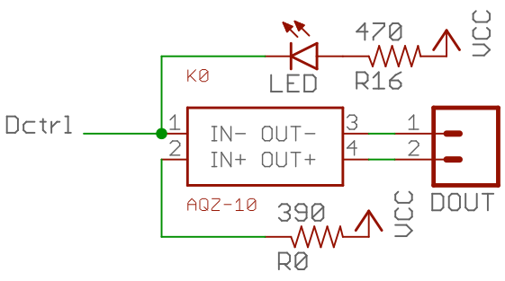

Programming an output bit (Drain_{n}) with a '1' produces a low-impedance condition to ground. This will cause current to flow from Vcc through the LED (illuminating the LED) as well as current to flow through the SSR (and through the LED inside it) to ground. This, coincidentally, creates a low-impedance (closed) circuit across the DOUT terminals. Programming an output bit with a '0' creates a high-impedance state in the TPIC6B595 channel's FET, thus prevent current from flowing through these two LEDs. This produces a high-impedance state across the DOUT terminals (effectively creating an open circuit).

The circuit above is replicated 16 times for each of the 16 channels on the PPSSR-16:

Please be aware that the RB0..RB15 signals from the two TPIC6B595 chips do not directly correspond to digital outputs D0..D16 on the PPSSR-16 board. The output pins were routed to the closest solid-state relays on the board to improve the quality of the circuit board layout. It is up to the software to translate bit positions shifted in to the corresponding outputs on the PPSSR-16 circuit board. This, of course, is always subject to change with revisions of the circuit board.

The PPSSR-16 design uses AQZ-10 Form A Solid-State Relay modules. This SSRs provide up to 2A current at 30 VDC. Each SSR is connected to a two-pin screw terminal for interface to external devices.

In order to achieve a full 2A control, the traces on the circuit board should be at least 50 mil wide and there should be traces on the top and bottom sides of the boards to allow for as much heat dissipation as possible (this size keeps the PCB temperature rise well below 10C). Note that standard engineering practice dictates derating the current to ½ the maximum rating (i.e., 1A), so 50 mil traces (particularly, two of them) will more than handle this. This design doesn't put copies of the traces on the interior layers because of heat dissipation issues. With 1oz copper, traces top and bottom are more than sufficient.

As per the TPCI6B595 data sheet, pins 1, 10, 11, 19, and 20 should be soldered to a large pad to serve as a heatsink for the device. In addition, to improve heat flow to this heatsink, the TPIC6B595 IC should be solder directly to the board (do not use a socket). The underlying copper connected to these pins should not use "thermals" (cross-hatches rather than solid copper connections) as the whole point is to move heat away from these pins as efficiently as possible. Of course, this will make soldering (and desoldering, if it comes to that) a bit more difficult; however, having the solid thermal connection will improve the life of the chip.

PPSSR-16 Buffered Signal Lines
- [DAQ_HDD_025]

The PPSSR-16 may not present more than one TTL load to any bus signal passed along the PPDO bus to multiple boards. for this reason, the PPSSR-16 board includes a quad tri-state buffer chip (74HC125) that buffers the following four signals:
- BS0
- SPI-CLK (SCK)
- RESET (RST)
- WD_LATCH

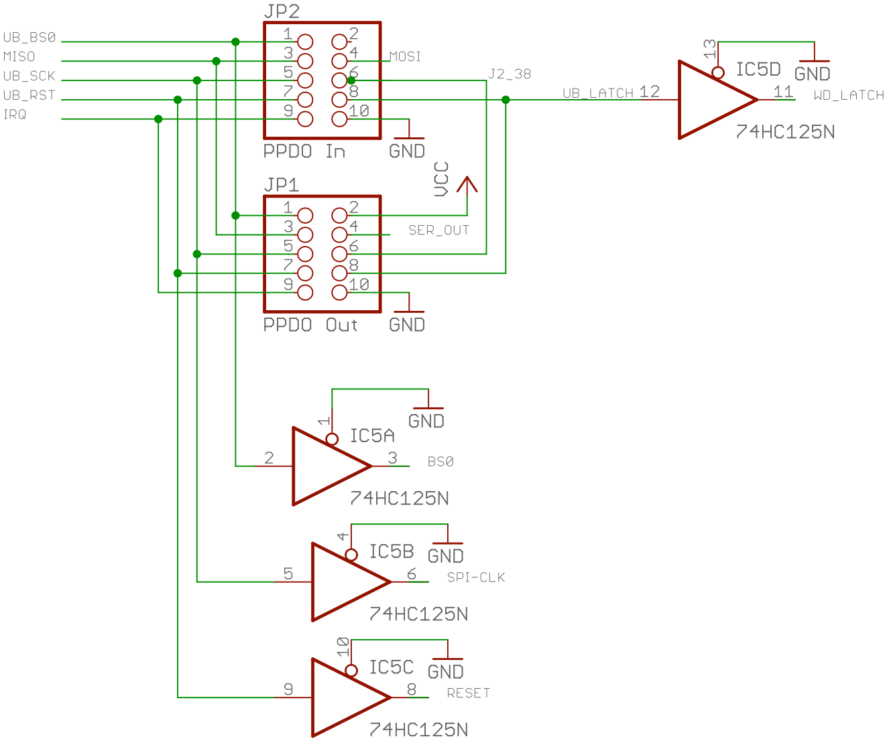

Technically, the SPI-CLK (SCK) signal should be gated by the BS0 line to avoid shifting in garbage while the DAQ system is communication on other SPI busses (e.g., the PPDIO96 bus). However, it doesn't harm anything to shift garbage through the shift registers if the system never transfers the data to the output latch (via the BS0 signal). The PPSSR-16 board only shifts data on the rising edge of the BS0 signal (which occurs, presumably, after the software has shifted valid data into the shift registers) or when a RESET or WD_LATCH signal occurs (in which case SRCLR has been pulled low and any garbage shifted in has been cleared).

PPRELAY-12 12-Channel Mechanical Relay Board

Capacity and Interface
- [DAQ_HDD_026]

The PPRELAY-12 board provides 12 channels of mechanical relay control for digital output devices. It also provides 4 bits of open-drain high current (sinking: 150 mA per pin) digital I/O. It provides 12 sets of screw terminals (three terminals each: NO/COM/NC – normally open/common/normally close) as outputs and a pair of 10-pin (2x5) headers that connect to the PPDO connector on the DAQ_IF board and provide a daisy-chain output to another output board.

The board utilizes JZC-11F-05VDC – 1Z relays that contain both normally open and normally closed contacts. There are board-layout-compatible relays available that drop the NC contact (providing only a normally-open contact) as well.

The PPDO input connector is a 10-pin header (2x5) with the following signals:

Pin | Description | Pin | Description
1 | Output: BS0 (SPI Chip Select) | 2 | N/C
3 | Input: MISO (SPI input) | 4 | Output: MOSI (SPI output)
5 | Output: SPI Clk | 6 | I/O: J2_38
7 | Output: RESET | 8 | Output: WD_LATCH
9 | Input: IRQ | 10 | Gnd

The PPDO output connector is nearly identical, with the following signals:

Pin | Description | Pin | Description
1 | Output: BS0 (SPI Chip Select) | 2 | Vcc
3 | Input: MISO (SPI input) | 4 | Output: MOSI (SPI output)
5 | Output: SPI Clk | 6 | I/O: J2_38
7 | Output: RESET | 8 | Output: WD_LATCH
9 | Input: IRQ | 10 | Gnd

The differences are on Pin 2 and pin 4. The input connector (+5V from the previous board in the daisy-chain) is left disconnected on the input connector. Pin 2 is connected to Vcc (+5V) on the output connector. Pin 4 on the input connector is tied to the serial in pin of the first TPIC6B595 serial shift register. Pin 4 on the output connector is tied to the serial out pin of the second TPIC6B595 IC (Serial data flows into the first shift register, out of the first and into the second shift register, and then out of the second shift register and to the output connector).

As the PPRELAY-12 board is a digital-output-only board, the PPRELAY-12 ignores the MISO input pin.

Power Supply
- [DAQ_HDD_027]

The PPRELAY-12 receives +5V power and ground on a two-pin screw terminal. As with most DAQ system boards, there is an LED connected to the power supply to indicate when power is applied.

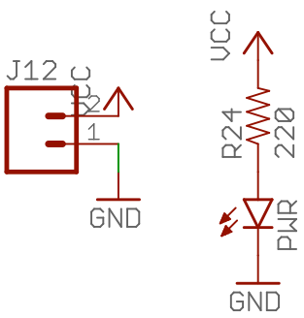

The greatest power use on the board will be the current required to actuate the mechanical relays. The JZC-11F-05VDC – 1Z relay has a nominal coil resistance of 320 Ω. At 5V the coils will draw less than 20 mA. Therefore, absolute worst case, is 12* 20mA or 240 mA of current actuate all relays. In addition to the relay coil, there is an LED associated with each output channel that illuminates whenever the SSR is actuated. These LEDs have a 470 Ω resistor, so each LED will also consume just under 15 mA. Of course, the rest of the board also draws current, so it's not unreasonable to expect upwards of 500-600 mA to be pulled from the power supply when all relays are actuated.

Note that the power switched by the relays is (theoretically) independent of the power supplied to the board. Unless you are powering some external circuit being switched by the relays from the PPRELAY-12's power supply, their power usage doesn't count towards the power used by the board.

PPRELAY-12 Board Select Signal (BS0) and Clocking Data into the PPRELAY-12
- [DAQ_HDD_028]

The PPRELAY-12 contains three input signal lines that control shifting data into the TPIC6B595 shift register and transferring that data to the output latches: BS0, SPI-CLK, and MOSI. These three signals correspond to three of the four SPI control lines (CS, SCK, and MOSI; as an output line the fourth SPI control line, MISO, is not used).

Note: although the PPRELAY-12 board uses the SPI control lines, the PPRELAY-12 isn't, technically speaking, an SPI device. It just so happens that the SPI clock and MOSI lines work fine as inputs to the TPIC6B's shift in and clock inputs. This "grand coincidence" allows the DAQ system to use the SPI bus to control shift-register-based digital output boards (e.g., PPSSR-16 and PPRELAY-12) on the system SPI bus.

To shift data into the two TPIC6B595 shift registers on the PPRELAY-12, the system should first switch the BS0 (board select 0) from high to low. The BS0 signal must be held low for the entire shift duration. Note that if you connect multiple PPRELAY-12 (and PPRELAY-12) boards in a daisy-chain on a single PPDO bus (i.e., off a single DAQ_IF board) then you must hold BS0 low while shifting out the bits for all boards. For example, if you have three output boards connected in a daisy chain, you need to hold BS0 low while shifting out all 48 bits for the three boards.

The TPIC6B595 shift registers shift the data present on the SER_IN pin into the shift register on the rising edge of the SRCK (SPI-CLK) signal. As in turns out, this is the exact waveform you want when transmitting data on the SPI bus. The bit shifted out appears on the SER_OUT pin that you normally feed to the input of any additional TPIC6B595 ICs in the chain.

On the rising edge of the BS0 signal, the PPRELAY-12 boards copy the bits in the shift register over to the output latch. To transfer the bits, a rising-edge clock signal must appear on the TPIC6B595 RCK input. The PPRELAY-12 synthesizes this clock by putting a positive-edge detection circuit on the BS0 input:

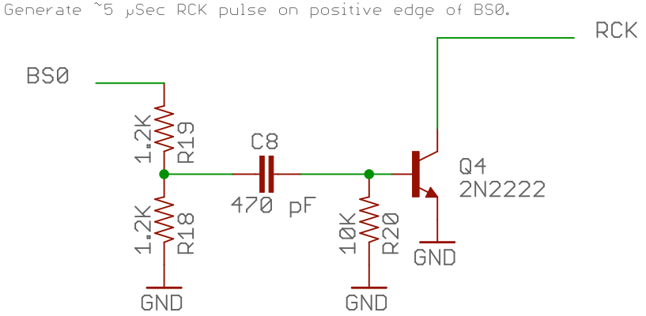

On the rising edge of the BS0 signal the transistor momentarily (about 5 µSec = C6 * R35) conducts pulling the RCK signal low for that time period. On the rising edge of that 5 µSec pulse (which occurs at least 5 µSec after BS0 has gone high) the TPIC6B595 shift register copies the data from the input shift register to the output latch.

PPRELAY-12 Power-On Reset, Watchdog Latch, and the Reset Signal
- [DAQ_HDD_029]

The PPRELAY-12 board, by requirement, must enter a "fail-safe mode" whenever power is first applied, whenever there is an explicit reset operation (a low pulse on the reset pin), or whenever the DAQ system has a watchdog timeout (low signal on the WD_LATCH input pin).

A "fail-safe mode" is defined as follows:
- If no power is applied to the PPRELAY-12 board, the JZC-11F-05VDC – 1Z relays remain in a deengergized (normally open) state. This state is guaranteed as the coils with no power level the relays normally open so the "unpowered" fail-safe condition is assured.
- On power-up the system remains in a fail-safe condition (deengergized relays) state until explicitly programmed to enter an engergized (closed) state.
- When explicitly told to reset, the system enters a fail-safe condition.
- When an anamolous condition (watchdog timeout) occurs, the system enters a fail-safe condition.

To handle the power-on reset requirement, the board includes a DS1834 power-on reset IC (with push-button input). The DS1834 provide three ways of generating a power-on reset signal:

- A power-on condition on a 5V power supply,
- A power-on condition on a 3.3V power supply, or
- An explicit reset request on a push-button input.

In the default state the PPRELAY-12 uses the first and third modes on to DS1834 to put the system in a "fail-safe" state.

Important note: there are several variants of the DS1834 IC. The DS1834 (no suffix) has an active-low RST output. The DS1834A has an open-collector RST output. The DS1834D has an active-high RST output. The PPRELAY-12 design utilizes the DS1834 (active-low) version.

The PPRELAY-12 uses a 5V power supply. Therefore, by default, the PPRELAY-12 uses the 5V side of the DS1834 to produce a power-on reset. The PPRELAY-12 board programs the DS1834 with a 10% tolerance. So if the voltage drops below (approximately) 4.5 volts (assuming a true 5V input) the chip with generate a reset pulse when power resumes. As it turns out, both the 5V and 3.3V sides of the chip will accept up to 5.5V on their input pins. The only difference is when they will produce a reset condition (4.5V or 3.0V). If your 5V power supply input to the PPRELAY-12 is right on the edge of 4.5V and you're getting spurious resets from the DS1834, you can choose to use the 3.3V power-on-reset function rather than the 5V power-on-reset function. This is accomplished using the DS1834SEL jumpers on the PPRELAY-12 board. Putting jumpers between pins 1 & 3 and pins 2 & 4 programs the device to use the 5V power-on-reset (this is the default). Moving the jumpers to pins 3 & 5 and 4 & 6 programs the DS1834 to use the 3.3V power-on-reset. Note that you're still feeding 5V to the chip (which, electrically, is okay). By using the 3.3V inputs you're providing a 40% tolerance factor rather than the normal 10% tolerance factor. Unlike the PPSSR-16 board (described earlier in this document) there may be good reason to use the 3.3V side of the DS1834. As you engergize each relay coil, you'll see a small voltage drop on the Vcc plane. With 12 relays, it's actually possible to drop the voltage to below 4.5V and cause the DS1834 to go into continuous reset mode.

Note: Severe voltage drops as just described can be avoided by doing two things: first, ensure that heavy gauge wiring (20 ga or better) connects the PPRELAY-12 board to a good +5V power source; second, use of 2 oz copper for the PCB can also help reduce voltage drops on the power plane (though, technically, the 2 oz is really desireable for the relay contact traces).

The reset output (5VRST or 3.3VRST, depending on the jumpers on DS1834SEL) is fed into a positive edge detector circuit (similar to the BS0 edge detector circuit) and this is connected to the RCK signal line (along with the collector on the BS0 edge detector). If either signal, BS0 or the DS1834 RST output, goes low, you get a negative-going pulse on the RCK (register transfer clock) input to the TPIC6B595 shift register.

Note that the time constant for the DS1834 RST edge detector is much longer than that of the BS0 edge detector (10 mSec for the DS1834 versus 5 µSec for BS0). The DS1834 PBRST input requires an active low-signal for at least 2 mSec. The time constant for the RCK pulse is 10 mSec because it is greater than or equal to the pulse being sent to the DS1834 (that triggers the RST pulse).

If, by some coincidence, both BS0 and the DS1834 RST signals occur are the same time, whomever holds the RCK line down the longest (usually the DS1834) will be the winner. Of course, if the DS1834 RST signal is active, the circuitry is clearing the shift register anyway, so ithe data shifting into the shift register will be irrelevant. One important feature, and in fact the main reason for implementing the edge detectors in the RCK signal circuit, is that the static state of either input signal (DS1834 RST or BS0) does not affect the operation of the other signal. That is, if BS0 is held low (or held high) it doesn't prevent the DS1834 from clocking the TPIC6B595 RCK line. Likewise, if the PBRST is held low (or high) it doesn't prevent BS) from generating a clock on the RCK line. Had this been just the logical NAND of the two signals, errant software could leave the BS0 line low (for example) and then the DS1834 circuit would not be able to clear the shift register and shift those zeros into the output latch (putting the system in fail-safe mode).

Note that there is no feedback to the DAQ system (other than putting the output latches on the PPRELAY-12 into fail-safe mode) that there has been a power failure and reset on the PPRELAY-12 board. If this is a possibility in your system design, you will need to add monitoring circuitry to check for this.

The PPRELAY-12 synthesizes the DS1834 input PBRST signal from two PPDO input signals: WD_LATCH and RESET. The WD_LATCH signal is active low whenever the watchdog timer has expired, the RESET signal (not to be confused with the DS1834 RST output) is active low whenever the DAQ_IF CPU module programs the system to do a reset operation.

The PPRELAY-12 circuit feeds the WD_LATCH and RESET signals into edge detector circuits and combines their outputs to feed the PBRST input on the DS1834 IC.

Note that this circuit inverts the two input signals. Therefore, the positive-edge detector circuits are actually producing pulses on the negative-going edges of these two signals (that is, on the leading edge of the RESET and WD_LATCH pulses, which are normally active-low pulses). Because the PBRST input on the DS1834 IC requires an active-low signal at least 2 mSec in duration, the time constants on the two edge detector circuits is 10 mSec. This means that these signals should be held low for at least 10 mSec to guarantee a full 10 mSec output pulse.

Note that pulsing (low) the RESET or WD_LATCH line will (eventually) generate a pulse on the RCK line. This, alone, however, does not put the system into the fail-safe state. Pulsing RCK will transfer the current data from the TPIC6B595 shift register to the output latch; however, if the contents of the shift register are not zero this will not produce a fail-safe output condition. Therefore, activation of either RESET or WD_LATCH must also clear the shift register prior to transfering the data from the shift register to the output latch. The system must pulse (low) the TPIC6B595 SRCLR line to clear the contents of the shift register.

The PBRST signal is almost the signal needed to accomplish this. PBRST goes low whenever RESET or WD_LATCH become active. Furthermore, this signal will be low prior to the RCK clock pulse that PBRST generates, so the timing is perfect for the TPIC6B595 chip:

The only problem here is that to clear the TPIC6B595 shift register requires a rising edge on the PBRST line. Because of the edge detector circuitry, this rising edge is pretty much guaranteed around 10 mSec after PBRST first goes low because it is totally dependent upon the RC time constant in the two edge detectors (C5*R40 or C3*R37 in the previous schematic). For the reset signal, this is no big deal because software generates the reset pulse (and failure of the software to bring the reset signal high won't affect the behavior of this circuit).

The WD_LATCH signal, however, is generated in hardware (a watchdog timeout on the DAQ_IF board). This signal is set low whenever the watchdog timer times out and remains low until the CPU module on the DAQ_IF explicitly resets it to high by toggling the RESET line. Note that refreshing the watchdog timer (by pulsing the WD_RFSH line on the DAQ_IF board) will not clear the WD_LATCH low condition. Only an explicit active low signal on the RESET signal will set the WD_LATCH signal back to high. For most situations, a system designer would probably like to keep the output latches in their fail-safe state as long as the WD_LATCH signal persists. Some additional circuitry exists in the PPRELAY-12 design to allow this:

This circuit includes a 3-pin header that allows the system designer to select PBRST-only operation (only clearing the shift register on while PBRST is active low) or a combination PBRST or WD_LATCH active-low condition. If there is a jumper between pins 1 & 2 on the SCLR header, the system only resets the shift register while PBRST is low. If there is a jumper between pins 2 & 3 on the SCLR header, then the system will keep SRCLR held low as long as PBRST is low or WD_LATCH is low. By default, the boards have pins 2 & 3 jumpered, so as long as WD_LATCH is low the circuit will hold SRCLR low as well.

Remember that holding SRCLR low will only clear the shift register, not the output latch, on the TPIC6B595 IC. When WD_LATCH goes low this will clear the shift register (and keep it clear as long as WD_LATCH is low) and, ultimately, send a pulse to the RCK line to shift the data to the output latch. Continuing to hold the SRCLR line low will not generate any additional RCK pulses. However, should the software attempt to shift in additional data (by placing the data on MOSI, toggling SPI-CLK, and pulsing BS0 appropriately) holding the SRCLR line low will keep the input shift register in a cleared state so that when the rising edge of BS0 arrives the shift register is still clear and the output latch will remain in a fail-safe state.

It is hard to imagine a situation (in a fail-safe system) where you would want to disable the WD_LATCH low feature, but if this is what you need you can always put the jumper on pins 1 & 2 of the SCLR header.

PPRELAY-12 Outputs and Output LEDs
- [DAQ_HDD_030]

The PPRELAY-12 implements the 16 output channels using two 8-bit TPIC6B595 shift registers. The output pins on the TPIC6B595 (Drain₀..Drain₇) are open-drain FETs capable of sinking up to 150 mA each. Each of these lines (call it Dtrl) is fed to a solid-state relay and LED/resistor circuit:

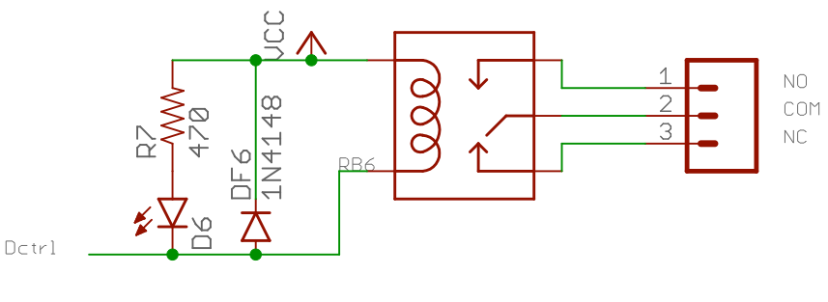
Programming an output bit (Drain_{n}) with a '1' produces a low-impedance condition to ground. This will cause current to flow from Vcc through the LED (illuminating the LED) as well as current to flow through the relay coil to ground. Programming an output bit with a '0' creates a high-impedance state in the TPIC6B595 channel's FET, thus prevent current from flowing through the LED and relay coil.

Note that the circuit includes a flyback diode across the relay coil. In theory, the TPIC6B595 includes this diode as part of the package. The documentation for the TPIC6B595 makes the following statement:

The device contains a built-in voltage clamp on the outputs for inductive transient protection. Power driver applications include relays, solenoids, and other medium current or high-voltage loads.

Of course, no design engineer in their right mind wouldn't automatically place a flyback diode in the circuit despite the data sheet claim. Hence their presence in this circuit.

The circuit above is replicated 12 times for each of the 12 channels on the PPRELAY-12:

The remaining four bits from the second TPIC6B595 IC are sent to an auxiliary output header providing extra digital output capabilities. Each pin on this connector is capable of sinking 150 mA of current.

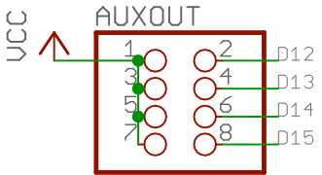

Please be aware that the RB0..RB15 signals from the two TPIC6B595 chips do not directly correspond to digital outputs D0..D15 on the PPRELAY-12 board. The output pins were routed to the closest relays on the board to improve the quality of the circuit board layout. It is up to the software to translate bit positions shifted in to the corresponding outputs on the PPRELAY-12 circuit board. This, of course, is always subject to change with revisions of the circuit board.

As per the TPCI6B595 data sheet, pins 1, 10, 11, 19, and 20 should be soldered to a large pad to serve as a heatsink for the device. In addition, to improve heat flow to this heatsink, the TPIC6B595 IC should be solder directly to the board (do not use a socket). The underlying copper connected to these pins should not use "thermals" (cross-hatches rather than solid copper connections) as the whole point is to move heat away from these pins as efficiently as possible. Of course, this will make soldering (and desoldering, if it comes to that) a bit more difficult; however, having the solid thermal connection will improve the life of the chip.

The PPRELAY-12 design uses JZC-11F-05VDC – 1Z Relay modules. These relays provide up to 5A current at 30 VDC with a very high isolation from the reset of the circuit. In order to achieve a full 5A control, the traces on the circuit board should be at least 100 mil wide and there should be traces on the top and bottom sides of the boards to allow for as much heat dissipation as possible (this size keeps the PCB temperature rise well below 10C). You will also want to use 2 oz copper boards in the design for additional current-carrying capability. Note that standard engineering practice dictates derating the current to ½ the maximum rating (i.e., 2.5A), so 100 mil traces (particularly, two of them) will more than handle this. This design doesn't put copies of the traces on the interior layers because of heat dissipation issues. With 2 oz copper, traces top and bottom are more than sufficient.

PPRELAY-12 Buffered Signal Lines
- [DAQ_HDD_031]

The PPRELAY-12 may not present more than one TTL load to any bus signal passed along the PPDO bus to multiple boards. for this reason, the PPRELAY-12 board includes a quad tri-state buffer chip (74HC125) that buffers the following four signals:
- BS0
- SPI-CLK (SCK)
- RESET (RST)
- WD_LATCH

Technically, the SPI-CLK (SCK) signal should be gated by the BS0 line to avoid shifting in garbage while the DAQ system is communication on other SPI busses (e.g., the PPDIO96 bus). However, it doesn't harm anything to shift garbage through the shift registers if the system never transfers the data to the output latch (via the BS0 signal). The PPRELAY-12 board only shifts data on the rising edge of the BS0 signal (which occurs, presumably, after the software has shifted valid data into the shift registers) or when a RESET or WD_LATCH signal occurs (in which case SRCLR has been pulled low and any garbage shifted in has been cleared).

Note: Using the ribbon cable interface may reduce isolation as higher-frequency signals may induce noise on other lines on the ribbon cable if it is not properly shielded or is sufficiently long.
Although PPRELAY-12 board possess only 12 relays, they are still 16-bit boards. Four of the output bits are sent to a header rather than controlling relays. Therefore, you must shift 16 bits for each board, regardless of whether it is a PPSSR-16 or PPRELAY-12 board.
Sadly, the SRCLR input only clears the shift register. It does not (asynchronously) also clear the output latch. This is a shame, almost all the edge detection circuitry used to synthesize RCK could have gone away if SRCLR cleared the output latch as well as the shift register.
Note that Rev 3 of the PPSSR-16 circuit board actually uses 100 mil traces on the top and bottom layers.
Although PPRELAY-12 board possess only 12 relays, they are still 16-bit boards. Four of the output bits are sent to a header rather than controlling relays. Therefore, you must shift 16 bits for each board, regardless of whether it is a PPSSR-16 or PPRELAY-12 board.
Sadly, the SRCLR input only clears the shift register. It does not (asynchronously) also clear the output latch. This is a shame, almost all the edge detection circuitry used to synthesize RCK could have gone away if SRCLR cleared the output latch as well as the shift register.

